Albuquerque
International
Balloon Fiesta®

Navigator Handbook

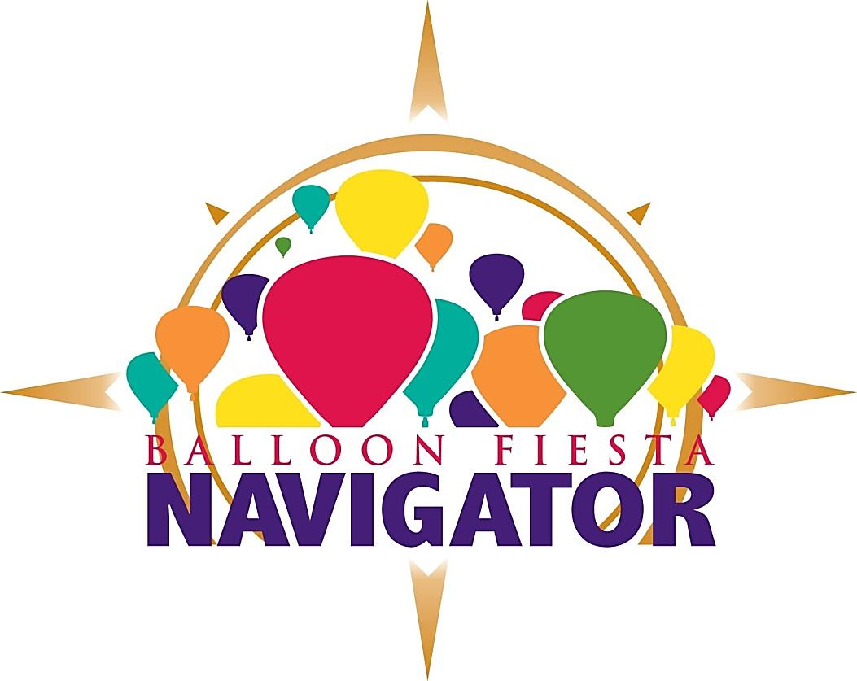

TABLE OF CONTENTS
NAVIGATOR CULTURE 6
ORGANIZATIONAL POLICIES 8
Definition of “Volunteer” (also known as a Navigator) 8
Role of the AIBF Board of Directors 8
Volunteer Classifications 9
Insurance for Navigators 9
CONDUCT AND ETHICS 10
Navigator Code of Conduct 10
Alcohol and Drug Policy 10
Confidentiality 11
Conflict Of Interest 11
Anti-Discrimination/Anti-Harassment Policy 11
Speaking on Behalf of Balloon Fiesta 12
Intellectual Property 12
Dress Code 12
Identification 12
Social Networking 13
Gratuities 13
Reimbursements 13
PROGRAM OUTLINE 14
What You Can Expect 14
Recruitment 14
Recruitment and Equal Opportunity 14
Applications 15
Emergency Contact and Medical Condition Information 15
Voluntary Work Agreement 15
Background and Motor Vehicle Department Checks 15
Acceptance and Appointment of Navigators 15
Team Assignments and Transfers 16
Supervision 16
Training 17
Navigator Dismissal 18
Grievance/Complaint Procedure 18
SAFETY, SECURITY AND LOSS PREVENTION 20
Public Safety 20
Emergency Procedures 20
Lost Persons Procedures 21
Personal Safety and Security 21
Use of AIBF Vehicles 21
Vehicle Safety Rules 22
AIBF Property 23
Handling Money 23
NAVIGATOR BENEFITS 24
Minimum Work Requirements 24
Workamping 26
Accommodation Discounts 26
Event Discounts 27
Volunteer Recognition 27
Merits 27
EVENT POLICIES 30
Distribution of Printed Material/Signage 30
Gates/Public Admission 30
Unauthorized Access 30
Vehicle Access 30
Inappropriate Behavior 30
Media 30
Product Sales 31
Street Closures and Traffic Plan 31
Delays and Cancellations 31
APPENDIX 1 – FORMS 48
Incident Report 48
Cash Count Worksheet 48

Welcome to Albuquerque International Balloon Fiesta, Inc.

Thank you for joining Albuquerque International Balloon Fiesta, Inc. (AIBF) team of Navigators! You have the opportunity to make a great contribution to the sport of ballooning, the city of Albuquerque and the state of New Mexico, and we hope that you will find your time here to be a rewarding experience.

You have joined an organization that has established an outstanding reputation for hospitality, quality and safety. Credit for this goes to everyone in the organization. We hope you, too, will find satisfaction and take pride in your work here. As a member of AIBF's Navigator team, you will be expected to contribute your talents and energies to further improve the environment and quality of the event.

This Navigator Handbook should provide answers to questions you may have about AIBF's Navigator program, policies and procedures. You are responsible for reading and understanding this manual.

I extend to you my personal best wishes for your success and happiness at AIBF.

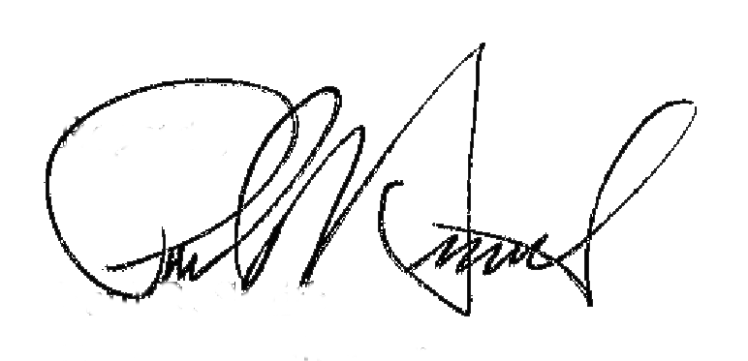
Regards,

Paul R. Smith
Executive Director

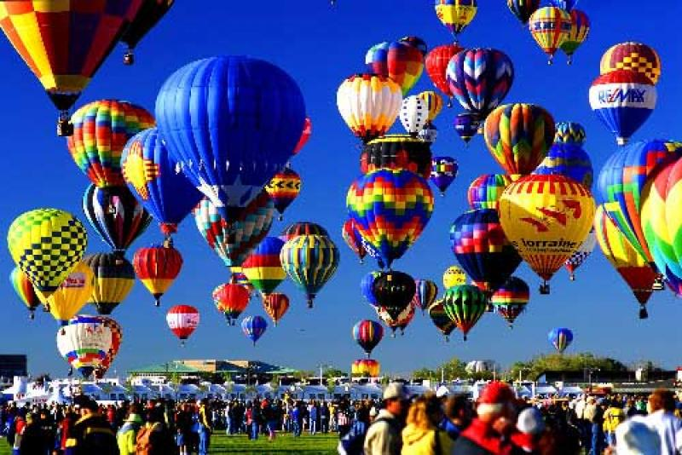

This Navigator Handbook has been prepared to inform you of AIBF's history, philosophy, volunteer program policies and procedures, as well as the benefits provided to you as a valued Navigator.

The policies in this Navigator Handbook are to be considered as guidelines. AIBF, at its option, may change, delete, suspend or discontinue any part or parts of the policies in this Navigator Handbook at any time without prior notice as business, legislation and economic conditions dictate.

Any such action shall apply to existing and future Navigators.

No statement or promise by a Team Leader or AIBF Staff Person, past or present, that is in conflict with this manual may be interpreted as a change in policy nor will it constitute an agreement with a Navigator.

This Navigator Handbook replaces (supersedes) any and all other or previous Navigator Handbook, volunteer handbooks or other AIBF policies whether written or oral.

Updated 10-23-17. This version supersedes all previous versions.
NAVIGATOR CULTURE

We can outline and enforce policies and procedures, but the “culture” behind an organization is what makes it positive – or negative. Below are the do’s and don’ts we hope you’ll embrace to generate a positive culture of outstanding service.

Imagine planning your dream vacation. You hope that everything will meet your expectations. You are, after all, spending your hard-earned dollars for the experience. Imagine, perhaps, that this is the biggest vacation you’ve taken in a long time – maybe ever.

This could be true for the hundreds of thousands of guests, hundreds of pilots, crew, Navigators, sponsors or media who come to Balloon Fiesta. And whether this is their first visit or their 45th, they should have the same outstanding experience. It’s up to you to make that happen for each person you come in contact with.
Don’t:
- Ignore safety procedures and policies. Safety is the number-one priority at the event.
- Lose patience when asked the same question by guest after guest. It’s their first time asking the question. If you find that the same question is asked repeatedly, then consider that we’re not doing our job in informing the guests, and keep a list to give to the Staff Person who oversees your area.
- Bad-mouth, vent or gossip about Balloon Fiesta, its staff, board, other Navigators, or anyone else at the event. We understand that things don’t always run smoothly, and you might run things differently if it was up to you. Everyone is doing their best. Negativity doesn’t help anyone.
- Work too many shifts. It doesn’t serve anyone if you’re exhausted and short-tempered.
- Party too much. While Balloon Fiesta is a great time to reconnect with your friends, you’re still expected to be at the top of your game for each and every shift. Take it easy on the parties, late nights and alcohol.
Do:
- Treat everyone with respect and compassion.
- Understand their enthusiasm and, at times, frustration.
- Make the best possible choices you can to make sure the guest is valued and served.
- Greet each session with “beginners’ eyes” and see the event as if you’re attending for the first time.
- Take care of yourself. Eat. Rest.
- Ask for help. We do our best to fully staff every Navigator team. There are plenty of people willing and eager to help.
- Buddy up. Ask a trusted fellow Navigator to point out if you’re getting impatient or short-tempered.
- Remember what makes Balloon Fiesta enjoyable for you and reconnect with that.
- Take advantage of the merit classes and trainings being offered through AIBF. This will deepen your skills and expand your knowledge – all reigniting your commitment to offering great guest service.
- Have fun, make friends, and enjoy the event!

Why “Navigator”?

Navigate
[nav-i-geyt]
verb (used with object), navigated, navigating.
1. to move on, over, or through (water, air, or land) in a ship or aircraft:
“to navigate a river”
2. to direct, guide or manage a traveler on its course.
3. to ascertain or plot and control the course or position of (a ship, aircraft, etc.).
4. to pass over (the sea or other body of water), as a ship does.
5. to walk or find one's way on, in, or across:
“It was difficult to navigate the stairs in the dark”
6. to move or progress through in a logical sequence:
“Headings and subheadings make it easier to navigate a long article”

Navigator
[nav-i-gey-ter]
noun
1. a person who navigates

Balloon Fiesta has graduated from being an annual Albuquerque festival to that of a world-renowned, world-class event. Balloon Fiesta volunteers play a crucial role in ensuring that the hundreds of thousands of Balloon Fiesta guests have a world-class experience. As a result, the guest experience can no longer be left to chance.

No matter what you do in your role as a Navigator – whether you pack pilot packs, service breakfast, drive a shuttle cart, fill propane, or any of the numerous roles you can serve – you are each in the role of offering outstanding guest (customer) service. Your guests may be the pilots, the general public, or other Navigators. Regardless – each of them deserve nothing less than world-class service.

So the “Above and Beyond Program” was developed to establish basic training guidelines, baseline policies and procedures, create community and encourage communication among the volunteers, and to encourage and reward all volunteers who go above and beyond in their dedication to service.

As part of this effort, AIBF volunteers were re-named as AIBF Navigators. The word Navigator embodies the role we expect you to play for our guests – offering guidance, showing them the way, and confidently leading them to everything they need to have an outstanding experience.

As sometimes happens in organizations that depend on unpaid helpers, “volunteers” may become devalued over time. And those very same volunteers may never fully take ownership of their role – hiding behind the term “volunteer” to mean someone without responsibility, accountability, or value. Renaming our volunteers is intended to remove some of the roles or habits that may have become entrenched with the term “volunteer.”

While we still fully recognize and honor that you are volunteering your time, effort and skills, we hope that you step fully into the role of Navigator, offering guidance, leadership and confidence to guests, pilots and crew, fellow Navigators and staff. Wear the title proudly and show the world that Albuquerque International Balloon Fiesta Navigators are as world-class as the event.
ORGANIZATIONAL POLICIES

Definition of “Volunteer” (also known as a Navigator)
A `volunteer' (Navigator) is anyone who, without compensation or expectation of compensation beyond reimbursement, performs a task at the direction of and on behalf of the Albuquerque International Balloon Fiesta. A Navigator must be officially accepted and enrolled by Balloon Fiesta prior to performance of duties. Unless specifically stated, Navigators shall not be considered employees of the agency.

Additionally, a Balloon Fiesta Navigator is an individual who, beyond the confines of paid employment and normal responsibilities, contributes time and service to assist the Albuquerque International Balloon Fiesta in the accomplishment of its mission.

Role of the AIBF Board of Directors
Board members serve as volunteer leaders of AIBF. The objective of the board is to partner with and provide guidance to the Executive Director in developing and managing mission-related activities, operations, fiscal management, growth, development and public relations for the event and organization.

While the Board may oversee programs, plans and the progress of various operations, they are not involved in staff or volunteer management, or operational decision-making.
Volunteer Classifications
Navigator – Individuals who have completed the Navigator application process, been assigned to a Navigator team, and completed all modules of the Navigator Basic Training. Navigators are under the direct supervision of an AIBF Staff Person, who may or may not be assisted by a volunteer Team Leader or Team Leaders. Navigators are critical to every area of operations, providing guest services, administrative services, balloon coordination and safety, set-up and logistics, on almost 40 different teams.

Team Leader – Navigators in a management, supervisory or assistant role to an AIBF Staff Person. Team Leaders fulfill many roles, including the interviewing and screening of potential team members, scheduling, area operations, and team management.

Chase Crew – While chase crew members volunteer their time in assistance to the Balloon Fiesta event, they are not considered Navigators or AIBF volunteers. AIBF will assist in recruiting chase crew for pilots participating in the event, but does not supervise, train, schedule, manage or assume any responsibility for the performance or actions of that person. Chase Crew members do not qualify for Navigator benefits.

Service Group – AIBF may contract management duties for various areas (admissions, parking, merchandise sales, etc.) to local organizations, who employ local service groups, non-profits, and other affiliated groups as volunteer labor to operate these areas. AIBF does not supervise, train, schedule, manage or assume any responsibility for the performance or actions of these groups. Service groups do not qualify for Navigator benefits.

Insurance for Navigators
In general, AIBF insurance covers Navigators while they performing volunteer duties for AIBF for:
- Liabilities they might incur while performing assigned AIBF duties
- Liabilities incurred as a result of accidents while driving an AIBF motor vehicle

AIBF will provide an accident insurance policy that will cover Navigators’ medical expenses incurred when performing duties as an AIBF Navigator up to $10,000. However, AIBF does not provide primary health/medical insurance and Navigators should turn to their personal health and medical insurance if injured.

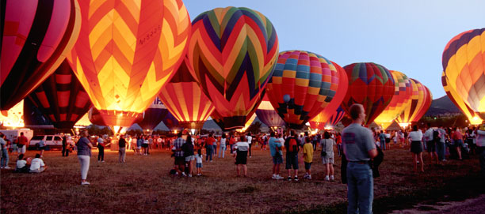

CONDUCT AND ETHICS

Navigator Code of Conduct
Navigators are representatives of the Albuquerque International Balloon Fiesta. Your actions reflect not only upon yourselves but also upon Balloon Fiesta, its board, staff and the other Navigators. Navigators should maintain the highest standards in the conduct of their activities so they and the Balloon Fiesta continue to be above reproach.

Each Navigator is responsible for conducting his or her duties and representing the organizations with integrity. This includes, but is not limited to:
- Putting the safety of all first.
- Treating everyone with respect, fairness and consideration regardless of race, gender, age, religion, ability, or sexual orientation.
- Working cooperatively as a team member with staff and other Navigators. If for some reason you cannot make your shift, contact the appropriate individual and let them know.
- Maintaining confidentiality of non-public information, and not acting upon such information for personal gain.
- Being truthful and accurate in all communications, records and reporting.
- Remembering this is a family event - keep language and behavior appropriate.
- Keeping personal opinions and actions separate from those made as a representative of AIBF. Remember when wearing your Navigator t-shirt, jacket, or other apparel you are representing the organization. If you are not “on duty” and do not wish to respond to guest inquiries, please dress in street attire. If you are wearing Navigator apparel, please do your best to get them the assistance they need, regardless of your duty status.
- Keeping AIBF staff informed of progress, concerns and problems within the area(s) volunteered.
- Avoiding any situation where personal interests are, or appear to be, in conflict with Balloon Fiesta interests.

Alcohol and Drug Policy
Being under the influence of alcohol or drugs can seriously impair an individual’s judgment and reactions leading to an increased risk of accidents and injuries occurring. The purpose of this policy is to ensure the safety of all Navigators by having clear rules in place regarding use and possession of alcohol and drugs.

No Navigator shall:
- Report or try to report for work when unfit due to alcohol or drugs (whether illegal or not) or to substance abuse
- Be in the possession of alcohol or illegal drugs in the workplace
- Supply others with illegal drugs
- Supply others with alcohol at Balloon Fiesta or at a Balloon Fiesta activity
- Consume alcohol or illegal drugs or abuse any substance while on duty, or at Balloon Fiesta, or at a Balloon Fiesta event/activity dressed in Navigator attire. The Navigator Appreciation Party is an exception to this.

Whether a Navigator is fit for work is a matter for the reasonable opinion of management.

In addition, Navigators must:
- Ensure they are aware of the side effects of any prescription drugs.
- Advise their Team Leader or a member of the staff immediately of any side effects of prescription drugs, which may affect work performance or the health and safety of themselves or others.

Violation of these rules constitutes misconduct and may be subject to immediate dismissal.

When there is a reasonable belief that an individual is under the influence of alcohol or drugs on reporting for work or during the course of work, the Navigator will be dismissed from service immediately. In addition, possession of, or dealing in illegal drugs on the premises will, without exception, be reported to law enforcement.

Confidentiality
Navigators are responsible for maintaining the confidentiality of all proprietary or privileged information to which they are exposed while serving as a Navigator, whether this information involves a single staff, Navigator, sponsor, guest, or other person or involves overall Balloon Fiesta business.

Conflict Of Interest
All Navigators shall immediately disclose any business, commercial or financial interest where such interest might be construed as being in real, potential or apparent conflict with their official duties of AIBF.

Anti-Discrimination/Anti-Harassment Policy
All Navigators have a right to work in an environment free from discrimination and harassing conduct, including sexual harassment. Harassment or discrimination on the basis of a Navigator’s race, color, religion, sex, sexual orientation, national origin, age, disability, veteran status, marital status, citizenship or any other characteristic protected by applicable law is expressly prohibited under this policy.

Any Navigator who believes he or she is being harassed or discriminated against, or any Navigator who becomes aware of harassment or discrimination, should promptly notify his or her Team Leader or AIBF staff. If the Navigator believes that the Team Leader or AIBF staff is the harasser or discriminator, or if a Navigator is uncomfortable discussing harassment or discrimination with his or her Team Leader or AIBF staff, the volunteer should contact the Event Coordinator.

Upon notification of a harassment or discrimination complaint, a confidential and impartial investigation will be promptly commenced and will include direct interviews with involved parties and where necessary with Navigators who may be witnesses or have knowledge of matters relating to the complaint. The parties to the complaint will be notified of the findings and their options.

This policy also expressly prohibits retaliation of any kind against any Navigator bringing a complaint or assisting in the investigation of a complaint.

Speaking on Behalf of Balloon Fiesta
While on assignment for the organization, Navigators will not represent themselves as other than a volunteer with AIBF.

If approached by the media under any circumstances, direct them to our Media Relations group.
The Director of Media Relations, the President of the Board of Directors and the Executive Director are the ONLY individuals authorized to discuss potentially controversial topics with the media.
Direct all media representatives to the Media Hospitality Area.

Intellectual Property
The Albuquerque International Balloon Fiesta name and logos are registered or copyrighted property and may not be used without express written permission.

Dress Code
Navigators working at the Balloon Fiesta are expected to dress appropriately for the event environment, maintaining good grooming and personal cleanliness. A neat and professional appearance is expected at all times.

Navigator shirts are provided each year. When available, additional shirts may be purchased at the Navigator Hospitality Tent at AIBF’s cost. It is preferred that Navigators wear this shirt throughout the current event, but Navigator/Volunteer shirts from previous years may also be worn.

Navigators may wear jeans, slacks, and shorts as appropriate for their area and tasks, but these and all other clothing items must be clean and neat. Torn or tattered items are not allowed.

If a Navigator earns a jacket for the current year, they are asked to wear that jacket, as it serves as a uniform, identifiable by the guest. Jackets from past years may also be worn, but must be clean and neat.

Various teams may require specific uniform items such as safety vests. Please discuss the proper attire for your job with your Team Leader.

Identification
All Navigators should have AIBF identification while performing their duties. Navigators will also be required to wear i.d. badges, indicating their name, title, team, and other pertinent information. These forms of i.d. must be worn at all times while working an assigned shift. These badges may also serve as access credentials, allowing entry into such locations as the Navigator Hospitality Tent or other areas. Public Safety may refuse entry to Navigators trying to enter without the appropriate identification.

Social Networking
Navigators are not required to act as AIBF advocates with personal social networking accounts.

Navigators are in charge of their own presence online. However, if Navigators do want to engage with support campaigns or other networking as it relates to AIBF, we ask that they follow these guidelines:
- Respect - Follow the Code of Conduct included in this policy manual. Any time a Navigator presents themselves as a representative of AIBF, they are expected to operate within these guidelines. Failure to do so may impact their status and position as a Navigator.
- Disclosure - If Navigators type, post or share anything about AIBF, it is the Navigator’s duty to disclose their relationship to the organization. Use your real name, identify that you work or volunteer for AIBF, and be clear about your role.
- Responsibility - Remember if you’re online, you’re on the record.
- Common Sense - The lines between public and private, personal and professional are blurred in social networking. By identifying yourself as AIBF Navigator, you are creating perceptions about your expertise and about Balloon Fiesta online.

Gratuities
AIBF prohibits the solicitation of any gratuities, and doing so is grounds for dismissal. It is preferred that unsolicited gratuities are not accepted. However, if refusing the gratuity will offend the guest, the Navigator may accept the gratuity and turn it in to the Team Leader.

Reimbursements
Navigators are not authorized to spend money on behalf of AIBF without prior authorization. Pre-authorized expenses incurred while fulfilling assigned duties may be reimbursed with submission of an Expense Reimbursement Authorization Form (see appendix), signed by the appropriate parties.

AIBF does not reimburse for mileage, parking expenses, meals, uniform cleaning services, refreshments, child care, telephone or postage expenses for work done at home, special clothing, or additional personal automobile insurance premiums necessitated solely by volunteer involvement.

PROGRAM OUTLINE

What You Can Expect
AIBF will Provide:
- A suitable assignment based upon your interests, skills and availability, as well as AIBF needs.
- Orientation and training to help you perform your job.
- The opportunity to work as part of a team, to contribute to the community and event, and to be recognized for your contribution.
- The support you need to do your job, including necessary equipment, supplies, work space and helpful supervision.
- The opportunity to give feedback about your AIBF volunteer experience.
- The chance to grow and develop as a volunteer through participation in other AIBF activities, special training events, meetings and more responsible positions.
- Proper supervision in an appropriate work setting.

Your responsibility as a Navigator:
- Be realistic and candid in accepting your assignment, taking into consideration your interests, skills and availability, as well as the needs of AIBF.
- Learn your volunteer assignment as well as you can by completing all required training, asking questions and staying in touch with your Team Leader.
- Contribute to AIBF by being reliable and dependable in doing your job and working with AIBF staff and fellow Navigators.
- Follow all policies and guidelines of AIBF, observe all safety procedures, and engage in appropriate public behavior at all times.
- Develop your skills as a Navigator by participating in training and development opportunities. Learn as much as you can to do the best job possible.

Recruitment
Navigators will be recruited without regard to gender, handicap, age, race, sexual orientation, or other condition. However, some assignments will require certain physical abilities. Recruitment will also focus on supporting the mission of AIBF, as well as that of leveraging community resources and maximizing the trend of “volun-tourism” – visiting tourists interested in volunteering.

Recruitment and Equal Opportunity
AIBF does not discriminate against, nor does it tolerate discrimination against or harassment of, any person based on race, color, religion, sex, sexual orientation, national origin, age, disability, veteran status, marital status, citizenship or any other characteristic protected by applicable law. Volunteers are recruited based upon their skills, abilities and suitability to perform Navigator responsibilities.

Youth Navigators
Navigators under 18 years of age may fill certain Navigator positions. Staff members will evaluate the abilities and competency of all Navigators and assign appropriate, safe activities as availability and conditions permit. Youth Navigators shall not be placed in any position involving alcohol sales, crowd management or areas which may endanger them.

Youth ages 13-18 years old may volunteer in limited, specific group activities and settings under the direct supervision of adults (e.g., a group of scouts under the direction of leaders) upon approval by Event Coordinator and the Team Leader for that area.

Youths merely accompanying an adult Navigator are not considered a youth volunteer nor do they receive any Navigator benefits. All Navigators under the age of 18 must have a waiver signed by a parent/guardian.

Applications
All prospective Navigators must complete a Navigator Registration form, preferably online but hard-copy forms are available. This registration includes a waiver, contact information for the applicant, and emergency contact information. If registration is incomplete, the applicant cannot be placed. Applicants will not be allowed access to the event nor issued their Navigator Packs without a completed registration.

Emergency Contact and Medical Condition Information
It is the responsibility of each Navigator to regularly update their personal contact information and emergency contact information in their Navigator profile, available at http://www.balloonfiesta.com/operations/volunteering/navigator-central

When appropriate, Navigators with life-threatening or serious health conditions should notify AIBF staff and Team Leaders of the condition and what, if any action should be taken in the event of emergency.

Voluntary Work Agreement
Navigator positions are “at will” and neither the Navigator nor AIBF have entered into a contract regarding the duration of the relationship. Navigators are free to terminate their position at any time, with or without reason. Likewise, AIBF has the right to terminate, transfer, make changes in the nature of the volunteer assignment, or otherwise discipline a Navigator at any time, with or without reason.

Background and Motor Vehicle Department Checks
AIBF strives to maintain a safe and productive workplace with honest, trustworthy, qualified, reliable and non-violent volunteers and employees who do not present a risk of harm to their co-workers or others. AIBF reserves the right to perform, or a third party to perform, reference and background checks at any time. All background checks will be performed in accordance with applicable federal and/or state law.

Background checks may include volunteer history and education verification, criminal history, social security number verification and sex offender registry review, where available, and licensure and motor vehicle record if appropriate to the position. In conducting background checks, AIBF may use consumer reporting agencies to gather and report information in the form of consumer or investigative consumer reports. All reference and background check results will be maintained in a confidential file by the Event Coordinator.

Acceptance and Appointment of Navigators
Upon review of the application, the Navigator Coordinator will contact and interview the applicant, then either assign them to a team, or forward them to the appropriate AIBF Staff Person or Team Leader for an additional interview.

Upon being assigned to a team, the Navigator will then receive a formal welcome email notification.

Confirmation of active status may only be given by the AIBF Navigator Coordinator or other Staff Person. No Navigator shall begin performance of any position until they have been officially accepted for that position and have completed all necessary screening and paperwork.

Team Assignments and Transfers
No Navigator shall serve on more than one team, unless authorized by the Navigator Coordinator prior to the current year’s event. This practice is discouraged and only allowed in special circumstances.

Team transfers must also be approved by the Navigator Coordinator. If requested by the Navigator, this should be done in advance of the event, to accommodate any area-specific training and to assist the Team Leader in accurate scheduling. But team transfers may happen during the event in select instances.

Supervision
Team Leader
Supervision of Navigators will address the needs of both the Navigator and the organization. Every Navigator will have a clearly identified supervisor who will be responsible for day-to-day consultation, support, and direction. That supervisor will be a Team Leader(s). In some cases, teams do not have a Team Leader, in which case the AIBF Staff Person who oversees that area will act as supervisor.

Team Leaders and/or an AIBF Staff person are responsible for interviewing, scheduling and managing a Navigator once they have been assigned to a team. They are also responsible for area-specific communications, as well as enforcement of policies, training, discipline, and coordinating with the Event Coordinator on the status of all team members.

Team Leaders will liaise with the AIBF Staff Person, providing progress reports, notice of any problems or concerns, and/or input regarding Navigator work performance on an as needed basis.

Team Leader/s have the authority to interview, hire, or suspend Navigators, as well as the authority to recommend reassignment or dismissal.

AIBF Staff Person
An AIBF Staff Person will supervise and coordinate with a Team Leader(s). The AIBF Staff Person is responsible for communicating pertinent event and policy topics with the Team Leader(s), and ensuring that that information is communicated to team members.

AIBF Staff have the authority to interview, hire, suspend reassign or dismiss Navigators.

Navigator Coordinator
The Navigator Coordinator acts as the overall Navigator (Volunteer) Coordinator, and is responsible for recruitment and assignment of new Navigators, dissemination of training and information to Team Leaders, AIBF Staff and Navigators, development and enforcement of Navigator policy, and implementation of program developments as determined with or by the Executive Director and/or the Navigator Committee.

Team Leaders and AIBF Staff Persons will liaise with the Navigator Coordinator to fill teams, manage training and deal with conflicts, reviews and/or dismissals.

Executive Director
The Executive Director is responsible for overseeing the administration, programs (including the Navigator program) and strategic plan of AIBF.

Navigator Committee
The Navigator Committee is comprised of the Navigator Coordinator and AIBF board members. Their role is to coordinate with the Navigator Coordinator to develop and define the Navigator program, seek funding for any Navigator program initiatives, and convey and enforce decisions from the AIBF board or other committees as they relate to the Navigators. They also conduct recognition events and liaise with other board members to assess various Navigator teams during the event.

Chain of Command
Navigators should address any questions, issues or concerns first with a Team Leader. If the Team Leader is unavailable or unable to assist, then the issue should be taken up with the supervising AIBF Staff Person. If the question is about a general policy, or the Team Leader or AIBF Staff Person is unable or unavailable to assist with the issue, the Navigator should contact the Navigator Coordinator.

If issues arise that cannot be addressed by any of these parties, the Navigator Coordinator will determine the next course of action, and whether the Executive Director should be involved.

Training
Basic Training
In order to assure that all Navigators interacting directly with Balloon Fiesta guests are operating on the most current information common and available to all, basic training is required. It has been determined that online video training is the most convenient, accessible format for the majority of Navigators.

Navigators are required to watch 5 Basic Training videos and take the quiz associated with each video, receiving a grade of 80% of higher.

The video topics are, and must be renewed as follow:
TOPIC | MUST BE RENEWED
Event Information  A snapshot of the details, logistics and specifics of the Balloon Fiesta event - gate times, prices, locations, and more | Every 1 year
Balloon Fiesta Safety and Security  An overview of how the Public Safety team ensures that Balloon Fiesta is one of the safest events in the country, and how Navigators can help support their efforts | Every other year
Ballooning 101 – Parts I & II  The basics of hot air balloon flight and balloon events during Balloon Fiesta | Every 5 years
Guest Service  The most important principles to providing top-notch guest (customer) service | Every 5 years

AIBF acknowledges that some Navigators may not have access to computers or the internet, therefore use of AIBF computers are available by appointment so that Navigators may access these trainings.

Navigator packets may be withheld until the above video training modules are completed.
Area-Specific Training
Individual areas may involve additional training and/or orientation. The schedule and minimum requirements for that training is to be determined by the AIBF Staff Person responsible for that area, in cooperation with the Team Leader, if applicable. They will also determine and communicate to the Navigator if this training is mandatory in order to serve on that particular team.

AIBF staff and Team Leaders are not required to accommodate Navigators who are unable to participate in area-specific training. We recommend that if a Navigator cannot participate in any mandatory training that they be reassigned to a different team.

Navigator Dismissal
Navigators who do not adhere to the rules and procedures of AIBF or who fail to satisfactorily perform their volunteer assignment are subject to dismissal.

Dismissal
Navigators may be discharged without warning. AIBF has the right to request a Navigator to leave immediately.

Grounds for immediate dismissal may include, but are not limited to:
- Gross misconduct or insubordination
- Being under the influence of alcohol or drugs while performing volunteer assignment
- Theft of property or misuse of AIBF funds, equipment or materials
- Lies or falsification of records
- Illegal, violent or unsafe acts
- Abuse or mistreatment of guests, AIBF Staff, fellow Navigators, or other parties
- Failure to abide by AIBF policy or procedure
- Failure to meet physical or mental standards of performance
- Unwillingness or inability to support and further the mission of AIBF
- Actions, attitude or behavior that undermines the ultimate goal of maintaining a safe event and offering outstanding guest service

Team Leaders may immediately suspend a Navigator. AIBF Staff may immediately dismiss a Navigator.

Grievance/Complaint Procedure
Navigators should promptly report a concern to his or her Team Leader. The Team Leader will investigate the matter, report the issue to the AIBF Staff Person, and take appropriate action.

Any Team Leader or AIBF Staff Person who receives a concern alleging a violation of the Harassment Policy will notify the Navigator Coordinator immediately. Navigators are strongly encouraged to follow the steps listed below to discuss any concerns with their supervisor.

If the concern the Navigator is having involves his or her Team Leader, the Navigator should report his or her concern to the AIBF Staff Person who will review the situation. If the AIBF Staff Person reviews the situation and cannot resolve the issue, the Navigator will be notified for further action.

If the problem is not resolved by the AIBF Staff Person, the Navigator is encouraged to seek assistance from the Navigator Coordinator. In an effort to resolve the problem, the Event Coordinator will consider the facts, conduct an investigation, review the findings and recommendations with Executive Director and respond back to the Navigator. The Navigator may be asked to put the concern in writing and provide appropriate documentation.

If a Navigator is not satisfied with the decision of the Navigator Coordinator, he or she may prepare a written summary of the concerns and request that the matter be reviewed by the Executive Director. In these instances the decision of the Executive Director is final.

If the Navigator’s concern involves the Executive Director the volunteer should report his/her concern to the Navigator Coordinator who will notify the AIBF Board President and undertake an investigation. The investigation will include a full examination of the facts (which may include a review of the written summary of the Navigator’s statement, discussions with individuals concerned, and a further investigation if necessary) and will advise the Navigator of its decision. The decision of the AIBF Board President is final.

SAFETY, SECURITY AND LOSS PREVENTION

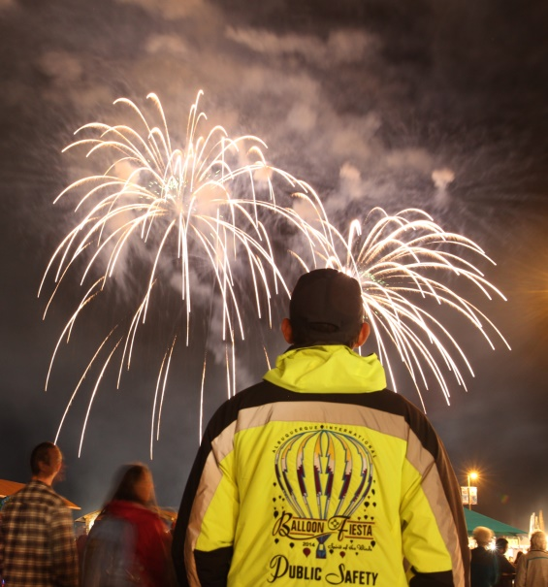
Public Safety
As a Navigator, Albuquerque International Balloon Fiesta requests that you recognize emergencies quickly, calmly and accurately. All Navigators are encouraged to constantly be alert for potential hazards to public safety.

All safety concerns, including suspicious behavior, persons or packages, should be immediately directed to the Public Safety Command Post just east of Main Street and south of the stage. You may also contact Public Safety by calling 505-821-7300 from any telephone.

IN ANY EMERGENCY SITUATION, DO NOT PLACE YOURSELF OR OTHERS IN DANGER!

Emergency Procedures
In the event of any type of life-threatening emergency to the guests of Balloon Fiesta, the directions of the appropriate professional authority (e.g. Police Department, Fire Department) shall take precedence. Balloon Fiesta procedures are designed to provide a basic model to follow in emergencies, but do not take priority over professional “on the scene” control of specific situations.

On-field assistance includes Albuquerque Police Department, (including the bomb squad), Albuquerque Fire Department, New Mexico State Police, Bernalillo County Sheriff’s Office, US Marshall’s office, Immigration and Customs Enforcement (ICE), FBI and Homeland Security.

When handling any emergency situation, report it clearly, calmly and accurately to the Public Safety Command Post (the building directly east of Main Street and just south of the stage) by phone or in person. If your duties require the use of an AIBF radio there will be an emergency channel to contact Public Safety.

- Remain calm; do not panic.
- Follow all instructions from the leads, staff or public safety officials.
- Maintain alertness and work with a Navigator buddy.
- Do not spread rumors. Refer all media questions to the media tent.

The priority for all paid security and volunteer Balloon Fiesta personnel shall be the enforcement of the organizational security guidelines. Sworn Police Officers shall assist Balloon Fiesta personnel in the enforcement of Balloon Fiesta guidelines as they become or are made aware of specific situations of violation.

Lost Persons Procedures
Lost Adults
Lost adults should be directed to leave messages for their party at the Public Safety building.

Adults Reporting Missing Children
Remain calm and obtain a complete description of the lost child, including age, height, hair color and clothing. Briefly search the immediate area. If child is not located, immediately notify team lead, staff and Police/Public Safety. Follow instructions made by Police/Public Safety.

Encountering a Lost Child/Child And Reporting Missing Adults
- Remain calm. Introduce yourself with your name and state that you are a Navigator with AIBF and will help them find their adult(s). Reassure that child that they are safe.
- Obtain a description of the adults, if possible, including names, age, clothing, hair color, approximate height and weight, who else is with them and any other details that may help. If a child is uncommunicative, notify Public Safety.
- Stay with the child and ideally in the same location. Often the adults are busy searching for the child and it is easier for them to come to you.
- Ask another Navigator to notify the appropriate personnel.
- In some cases a child may be more comfortable with another Navigator (i.e., male vs. female, older vs. younger, etc.). Do not take this personally.
- At no time should a child be left unaccompanied.
- Interest the child in conversation, your pins, or another novelty to calm them while other AIBF individuals work to find the adult(s).
- Follow any directions Public Safety may give you.

Personal Safety and Security
In order to provide a secure, safe and healthy work environment for volunteers, AIBF periodically provides information to Navigators about workplace safety and security issues through regular internal communication means such as emails, newsletters or other written communications.

Navigators are discouraged from bringing large amounts of cash or other personal valuables to work unless absolutely necessary. AIBF is not responsible for volunteers’ personal items that are lost or stolen.

Navigators should feel free to report, without fear of retaliation, any condition which they believe poses a safety, health or security risk in the workplace. AIBF will investigate such reports promptly and thoroughly and take appropriate corrective action. Further, any comments or jokes regarding threats of violence will be taken seriously, and dealt with appropriately and promptly.

In the case of accidents that result in injury, regardless of how insignificant the injury may appear, Navigators should immediately notify their Team Leader.
Use of AIBF Vehicles
Navigators may be required to drive a car, cart or other vehicle as part of their responsibilities. Navigators who drive as part of their responsibilities are required to do so in a friendly, courteous and safe manner. It is the policy of AIBF to make sure its drivers are qualified and legally authorized to safely operate motor vehicles used in the course of company business. Only those Navigators who meet the qualifications of the AIBF vehicle policy are allowed to operate AIBF vehicles or operate a personal vehicle on AIBF business.

Drivers are responsible for the safe operation of their vehicle. At no time are they permitted to subject an AIBF vehicle to abuse through careless or reckless operation.

Drivers are required to notify AIBF of license suspensions or revocations, and to report accidents or damage to company vehicles no matter how insignificant they appear within 24 hours. Drivers who fail to comply with these rules may face disciplinary action up to and including dismissal.

If provided, seat belts must be used at all times, by both the driver and all occupants of the vehicle. Failure to properly use seat belts will also be cause for disciplinary action. No volunteer, while operating an AIBF vehicle, or while driving his or her personal vehicle on AIBF business, may use a hand-held cellular telephone. Smoking is prohibited in AIBF vehicles.

No driver may operate a motor vehicle while the driver’s ability or alertness is so impaired, through fatigue, illness, taking medication or any other cause, as to make it unsafe for the driver to operate the vehicle. Volunteers who drive AIBF vehicles while under such conditions, which could impair their driving ability, face disciplinary action up to and including dismissal.

Drivers can be disqualified from driving vehicles for a number of reasons, including involvement in a number of accidents, or a demonstration of disregard for the safety of the public, as evidence by excessive speeding, reckless driving, driving under the influence, driving while his/her license is suspended or revoked, other evidence of reckless driving, failure to report an accident and/or breaking any motor vehicle laws.

Parking and traffic fines incurred while utilizing AIBF vehicles are the responsibility of the driver and will not be paid by AIBF.

Vehicle Safety Rules
These apply to golf carts, ATVs, mules, and any other AIBF vehicles:
- All drivers must carry a current, valid drivers’ license with them while operating the vehicle.
- All carts must be registered with AIBF and display a registration placard.
- Usage of carts will be solely for purposes related to the effective operation of the Balloon Fiesta.
- Driving under the influence of drugs and or alcohol will NOT be tolerated.
- No reckless or careless driving will be allowed.
- No open alcohol containers are allowed in cart while cart is in motion.
- Pedestrians have the right-of-way.
- DO NOT leave keys in an unattended cart.
- DO NOT make changes or modifications to ANY cart.
- The operator is responsible for any damage to the cart, ATV, or mule and also responsible for any damage or injury caused by operation of the cart.
- Navigators must drive the cart they are assigned. Carts will have individual identification numbers, letters, or other i.d. Note this identifying number and ensure you are entering the correct cart before driving.

- When picking up an assigned cart or vehicle, or taking over the cart or vehicle for your shift, inspect the vehicle, note any damage, and report the damage to your Team Leader before driving the vehicle.
- Immediately report to Public Safety if your cart is missing.

PUBLIC SAFETY AND ANY AIBF STAFF MEMBER HAS THE AUTHORITY TO WITHDRAW DRIVING PRIVILEGES FROM ANY OPERATOR IF AN INFRACTION OF ANY OF THE ABOVE RULES IS OBSERVED.

AIBF Property
AIBF works to prevent property loss of any kind. All property used to conduct business belongs to AIBF. AIBF assumes no liability for personal property brought into the workplace or any AIBF worksite.

Handling Money
There are to be two persons who are unrelated to each other counting cash, coin and checks. A Cash Count Worksheet (see appendix) must be completed and signed by each person and submitted with money that is turned in. If an adding machine is available, a tape needs to be run totaling the cash and checks.

All funds must be delivered DAILY to an AIBF employee and the Navigator MUST remain present while the employee counts the cash and checks. (This is for the protection of the Navigator.) If daily delivery of funds is not made, or if the funds counted by the AIBF employee do not match the cash count worksheet, the Navigators involved will be subject to disciplinary action.

NAVIGATOR BENEFITS

Minimum Work Requirements
Navigators are required to work a minimum of 4 shifts, but preferential assignments will be given to those who can work 5 or more shifts. Shift length may vary from team to team, but is, on average, 5 hours and coincides with a Balloon Fiesta “session.” There are 14 balloon event sessions and 1 Music Fiesta session.

Applicants who are unable to work a minimum of 4 shifts may be offered 1-2 shifts during Music Fiesta. It is otherwise recommended that applicants consider serving on a Chase Crew.

Benefits are distributed based on meeting the minimum work requirements.

Navigator Packs
Navigators who meet the minimum requirement of 4 shifts will receive a Navigator pack, which includes:
- Admission into the 9-day event
- Parking for the 9-day event
- Access to the Navigator Hospitality Tent for meals and snacks
- Invitations to a variety of Balloon Fiesta parties
- The current year's Navigator shirt
- The current year's Navigator lapel pin
- The current year's Official Event Program
- The next year’s calendar
Navigators who work a specific number of hours also get a Balloon Fiesta jacket. The number of hours varies from team to team, ranging from 5-7 shifts or 25-35 hours.

If the Navigator fails to meet the minimum requirements, they will be asked to return all items in the Navigator Pack, in their original condition, at no cost to AIBF. The AIBF Staff Person and/or Team Leader may then determine if the Navigator is welcome to volunteer at future events, and if so, whether any conditions may be appropriate.

Navigator Hospitality Tent
The Navigator Hospitality Tent is intended to provide food and beverages to all Navigators who are serving shifts during the Balloon Fiesta event, and in some circumstances, prior to the event, for activities such as Pilot Registration. Basic, simple food will be provided on a limited basis, as will beverages and light snacks. While AIBF will do its best to ensure that there is some food available at all times, it cannot be guaranteed that a full meal will be provided at all hours.

The Navigator Hospitality Tent is open the following hours:
Date | Tent Hours | Meals
1st Saturday | 3:45 a.m.– 10:30 a.m.  (Closed during Pilot Welcome Party)  1:30 – 7:30 p.m. | Breakfast | 4:30 a.m. until food is gone
 |  | Lunch | No lunch served today in the Navigator tent.  Lunch is available at the Pilot Welcome Party
 |  | Dinner | 4:30 p.m. until food is gone
1st Sunday | 3:45 a.m. – 7:30 p.m. | Breakfast | 4:30 a.m. until food is gone
 |  | Lunch | 11:00 a.m. until food is gone
 |  | Dinner | 4:30 p.m. until food is gone
Monday | 3:45 – 10:30 a.m. | Breakfast | 4:30 a.m. until food is gone
 |  | Lunch | No lunch served in the Navigator tent.  Lunch is available at the Navigator Appreciation Party
 |  | Dinner | No dinner service this day.
Tuesday | 3:45 a.m. – 1:00 p.m. | Breakfast | 4:30 a.m. until food is gone
 |  | Lunch | 11:00 a.m. until food is gone
 |  | Dinner | No dinner service this day.
Wednesday | 3:45 a.m. – Noon | Breakfast | 4:30 a.m. until food is gone
 |  | Lunch | No lunch served in the Navigator tent.  Lunch is available at the Pilot Picnic
 |  | Dinner | No dinner service this day.
Thursday | 4:30 a.m. – 7:30 p.m. | Breakfast | 4:30 a.m. until food is gone
 |  | Lunch | 11:00 a.m. until food is gone
 |  | Dinner | 4:30 p.m. until food is gone
Friday | 3:45 a.m. – 7:30 p.m. | Breakfast | 4:30 a.m. until food is gone
 |  | Lunch | 11:00 a.m. until food is gone
 |  | Dinner | 4:30 p.m. until food is gone
2nd Saturday | 3:45 – 10:30 a.m.  (Closed during Awards Party)  1:30 – 7:30 p.m. | Breakfast | 4:30 a.m. until food is gone
 |  | Lunch | No lunch served in the Navigator tent.  Lunch is available at the Hot Air Awards Party
 |  | Dinner | 4:30 p.m. until food is gone
2nd Sunday | 3:45 – 9:00 a.m. | Breakfast | 4:30 a.m. until food is gone

While socializing at the Navigator Tent is encouraged, loitering is not. Please do not neglect your volunteer shift.

Meals are intended for Navigators actively serving a shift. Navigators who are not working a scheduled shift, as well as friends and family of Navigators are asked not to eat at the Navigator Tent to ensure that there is enough food for those who are on shift.

Social Calendar
Navigators are invited to a variety of parties during Balloon Fiesta. Tickets are required to access each party, and the time, date and location will appear on the ticket.

Generally, these are the parties that are open to Navigators.
Date | Event | Hours | Location
1st Saturday | Welcome Party | 11:00 a.m. – 1:00 p.m. | Sid Cutter Pilots’ Pavilion
Monday | Navigator Appreciation Party | 11:00 a.m. – 1:00 p.m. | Sid Cutter Pilots’ Pavilion
2nd Saturday | Awards Party | 11:00 a.m. – 1:00 p.m. | Sid Cutter Pilots’ Pavilion

On the dates when parties are thrown, lunch will not be served in the Navigator Hospitality Tent.

Workamping
Many of our Navigators travel from out-of-state in their RV, and locals may request an RV space because of the hours they'll be volunteering. Therefore, Balloon Fiesta makes a limited number of RV spaces available to Navigators in trade for volunteer hours.

While Balloon Fiesta does not offer paid workamp positions, some Navigators volunteers who work additional hours may receive RV parking with hook-ups and other benefits when a certain level of volunteer hours is reached.

Workamper Requirements:
- Most workamp positions are allotted to the RV Team. Positions on the RV Team are limited, and assignment must be approved by the RV Team Leaders.
- Workampers will be required to work 120 total hours per person, working 4-5 hours per day.
- Workampers will need to arrive on or around Labor Day and work through Balloon Fiesta for 2-3 days following the event.
- Workamper tasks involve physical labor, such as pulling weeds, moving stones and rocks, and picking up trash in order to prepare the RV lots for the event.
- Workampers must meet the basic Navigator training requirements, which consists of watching four 30-minute videos each followed by a short quiz and a passing grade of 80% or higher.
While we would like to be able to accommodate all requests, we have a limited number of camping spots, and an even more limited quantity of premium campsites.

We will consider all requests that meet the following criteria:
We will consider all requests that meet the following criteria:
- 40-50 hours volunteered per person in 1 calendar year = 1/2 off dry camping (Normally $40/night)
- 51-120 hours volunteered per person in 1 calendar year = free dry camping (Normally $40/night)
- 121+ hours volunteered per person in 1 calendar year = free premium camping (Normally $90/night)

Hours will be verified with your Team Leader and you may be required to track your hours electronically. Navigators must abide by all standard rules and regulations that apply to RV camping.

Note: Out-of-town and out-of-state Navigators are given preference when awarding RV spaces. Local Navigators will be assigned an RV space based on availability.

Accommodation Discounts
AIBF does not guarantee, reimburse or offset any accommodation expenses for Navigators. However, AIBF negotiates a block of discounted rooms with HBC Event Services. Navigators who work 5 or more shifts qualify for access to these discounted rooms for personal use. Contact the Team Leader or Navigator Coordinator for instructions on how to access the hotel discounts. Discounts are available first come, first served.

Event Discounts
Navigators who work 5 or more shifts qualify for the following event discounts:
Ticket | Retail Price | Navigator Price | Restrictions
General Admission | $10 | $2.50 | Maximum quantity of 10 tickets per Navigator. Must be purchased online or in the AIBF gift shop. Not available for purchase at the gates.

Volunteer Recognition
AIBF is committed to recognizing Navigators in a variety of ways. The “Above and Beyond” Program was developed as a way to encourage and reward Navigators who go above and beyond in seeking to improve their skills, knowledge and value to the Balloon Fiesta event.

Merits
Navigators can earn a variety of merits, whether through training, skills or levels of responsibility. Merits are rewarded with a collectible lapel pin or certificate. Additionally, for each merit earned, the Navigator will be entered into a special drawing whereby they may win a “grand prize,” which is awarded at the Navigator Appreciation Party. Merits are considered “extra credit” and are not mandatory in any way.

Merit Trainings
CPR Training
Every Navigator who is trained in CPR exponentially enhances the safety and security of every person at Balloon Fiesta. AIBF is committed to making Balloon Fiesta the safest event possible. Navigators can earn the CPR Training merit in any of the following ways. However, only 1 CPR Certification Training Merit can be awarded every other year.

Class | Description | Restrictions | Award
CPR/First Aid Certification | 5-hour training recognized by the American Heart Association | May be renewed every other year; Navigators may attend free CPR Classes offered by AIBF or submit proof of CPR Certification | 1 Merit  1 Pin (to be awarded 1 time with initial certification)
Advanced Ballooning
AIBF believes that Navigators who are knowledgeable about all aspects of ballooning are better able to enhance the guest experience. Navigators can earn the Advanced Ballooning merit in any of the following ways. However, only 1 Advanced Ballooning Merit can be awarded per year.

Class or Qualification | Description | Restrictions | Award
Completion of the AIBF Advanced Ballooning Quiz | Basic Crew Skills Assessment Online Quiz | 1-Time Recognition; Quiz score of 80% or higher is required | 1 Merit  1 Pin (to be awarded 1 time with completion of quiz)
Crew Safety Seminar | 4-Hour hands-on Safety Seminar offered by AAAA | May be renewed bi-annually | 1 Merit  1 Pin (to be awarded 1 time with initial certification)
BFA Crew Achievement program (4 Levels of Crew Training) | Level 1 – Apprentice Crew | 1-Time Recognition for each level reached; Copy of BFA certificate must be submitted | 1 Merit  1 Pin (to be awarded 1 time upon completion)
 | Level 2 – Senior Crew |  | 1 Merit  1 Pin (to be awarded 1 time upon completion)
 | Level 3 – Crew Chief |  | 1 Merit  1 Pin (to be awarded 1 time upon completion)
 | Level 4 – Master Crew Chief |  | 1 Merit  1 Pin (to be awarded 1 time upon completion)
Hot Air Balloon Pilot | Possession of Hot Air Balloon Pilot’s Certificate (current within 10 years) | 1-Time Recognition unless additional licensing acquired, such as moving from private to commercial, or adding gas balloon rating | 1 Merit  1 Pin (to be awarded 1 time upon completion)

Additional trainings may be developed and/or offered.

Miscellaneous
Note that hours are non-transferrable between Navigators.

Other Merits
In addition to training, Navigators can earn credits in other ways.

Merit | Description | Requirements | Award
Team Leader | Official designation as a Team Leader for a Navigator area | Recognized each year | 1 Merit awarded each year of service as a Team Leader  1 Pin annually
Flex-Training | Gain experience volunteering in multiple areas | Volunteer in at least 3 different areas for 1 year each, then be available to fill in at one of those areas if they are short-staffed. | 1 Merit upon completion of 3-year rotation  1 Pin upon completion of 3-year rotation
Multi-Lingual | For Navigators who are fluent in a second language or American Sign-Language | Be available to the Public Safety team and other areas in the event that a guest or pilot needs a translator | 1 Merit (to be awarded 1 time)  1 Pin (to be awarded 1 time)
Refer-A-Friend | Refer someone who becomes a Navigator | Refer a friend or friends who become Navigators | 1 Merit for every 5 friends referred  1 Pin upon the first 5 friends referred. Pin embellishment for each additional 5 friends referred.

Anniversaries
AIBF recognizes Navigators for every 5 years of service. A pin will be awarded and the Navigators will be recognized at the Navigator Appreciation Party. If a Navigator takes a leave of absence, that year(s) will not be included in the calculation of the anniversary date.

EVENT POLICIES

Navigators are asked to observe and enforce the following policies. If you observe someone violating these policies, please notify Public Safety, AIBF Staff or your Team Leader.

ALL PERSONS, BAGS, AND VEHICLES ENTERING BALLOON FIESTA PARK ARE SUBJECT TO SEARCH

Distribution of Printed Material/Signage
Only printed material authorized by Balloon Fiesta may be distributed on Balloon Fiesta Park during the 9-day event. Any person distributing unauthorized material will be asked to dispose of the material or leave the park, under supervision. No one is authorized to distribute printed material (other than balloon cards) outside a rented booth.

Anyone distributing unauthorized material should be reported immediately to the Sponsor Information Center, located in the Golf Pro Shop west of the VIP/Sponsor Hospitality Area, south side of the field. Sponsor representatives can determine whether the distribution has been authorized.

No person is allowed to install, carry or hold a sign promoting any political candidate, political viewpoint or organization. Such signs should be treated as unauthorized printed material and reported to the Sponsor Information Center and the Public Safety Building.

Gates/Public Admission
All persons entering Balloon Fiesta Park via public admission gates must possess a valid ticket or credential, including Navigators. All Tickets must be surrendered, torn, or punched (as applicable). Gates open at 4:30 a.m. for morning sessions and 3:00 p.m. for evening sessions.

Unauthorized Access
Any person or vehicle determined to have gained unauthorized access to Balloon Fiesta Park shall be immediately removed by Public Safety.

Vehicle Access
All vehicles must have a valid vehicle pass to enter Balloon Fiesta Park. Vehicles without required passes or credentials will not be allowed access. Any vehicle on site without proper credential or in unapproved areas is subject to tow. Only Public Safety may authorize towing of any vehicle.

Inappropriate Behavior
All persons whose behavior is deemed inappropriate shall be brought to the attention of Public Safety. Should such behavior not be corrected or cause safety concern for other guests, the individuals involved shall be escorted from Balloon Fiesta Park by security guards or law enforcement officers. Admission tickets are revocable licenses and AIBF can decide to require a ticket holder to leave.

Media
All media are required to check in at Media Headquarters located in the tent directly south of the Sid Cutter Pilots’ Pavilion. No press may access Balloon Fiesta Park without the proper credential or without paying general admission charge.

All media engaged in inappropriate behavior should be reported (using credential information if possible) to Balloon Fiesta Media Headquarters.

Product Sales
No sales are allowed outside the booths on Main Street, with the exceptions of the sales of programs, calendars, and glow products by authorized vendors. Any violations of this rule should be reported to Public Safety.

Street Closures and Traffic Plan
Days and Times:
Weekend sessions 5-10 a.m.
5-9 p.m.
What Happens:
- Eastbound Alameda Blvd. is closed at Balloon Museum Drive.
- Westbound Alameda Blvd. is closed at San Mateo.
- Park & Ride (P&R) buses travel north on Jefferson to Balloon Fiesta Park.
- Northbound traffic on I-25 exits at Alameda Blvd. and is directed westbound under the bridge, then directed northbound on the frontage road or San Mateo to the general parking lots at Balloon Fiesta Park.
*During outbound operations, law enforcement will conduct the “flush” where all traffic lanes will become outbound. Eastbound Alameda will be closed at 2nd Street.

Delays and Cancellations
How is it determined if an event is cancelled?
The only reason a session may be cancelled is for the safety of the pilots, Navigators and/or guests at the Park. Please understand that while safety is the priority in this decision, the decision is not taken lightly. Balloon Fiesta understands there are tens of thousands of people, including guests, concessionaires and Navigators anticipating a successful event and have spent their time and money to see the balloons.

The first step in this process is for Weather Officials to advise the Safety Officials, Balloonmeister, Assistant Balloonmeister and Event Director of the weather conditions and forecasts at various times, locations and elevations that the balloons might encounter to determine if inflations are safe and feasible. Those officials then determine if inflation may proceed. If conditions are unsafe for inflation, a recommendation is then made to the Executive Director and President of AIBF to postpone or cancel the event. Occasionally, but not often, the weather conditions seem to be great on the ground at the Park but the winds just above the ground might be too fast or the weather forecast might include strong winds or other dangerous conditions in the near future.

When determining whether a session is "cancelled" and rain checks issued, balloon inflations are the determining factor, rather than flights. Both morning and evening events involve inflation, while glows do not involve flight. Generally the criterion for cancellation is whether or not a significant number of balloons are able to inflate.
From whom does that official announcement come?
Before the beginning of a balloon event the Executive Director and Event Director must coordinate with the Board President before a cancellation can be called. After the session has begun, the Balloonmeister has the ultimate authority to make the decision.

How do Navigators find out if a session is cancelled?
- The cancellation decision will be conveyed to the Information Booths and other interested parties by text messages. To sign up for these text messages, go to http://avirtualreceptionist.net/onlineSignup/BALLOON/text
- The Flight Officials will raise the red signal flag near the Sandia Resort & Casino Main Stage, in the center of Main Street, when balloon operations are cancelled. A yellow flag means that the decision is pending, and the green flag means that inflation is a "go!"
- Video walls will be present each of the Main Stage The cancellation message will be displayed on those walls.
- AIBF Staff will communicate with their Team Leaders as they are informed of event plans.

It's important to wait to receive the message from one of these official sources.

Media has sometimes heard a rumor and in an effort to "be first" has disseminated unverified information. The official message will also include a message whether rain checks will be issued for that session.

Please wait for the official message before relaying information to our guests.

Please do not speculate among yourselves, to the guests, to the media, or anyone else whether or not a session is cancelled. Wait for official confirmation.

What does a guest do if they've thrown away their ticket?
It's important to understand that we don't physically hand out physical "raincheck tickets". The normal process is that all tickets are scanned at any of the various gates. The information from those scans is uploaded to our ticket database and all those tickets are cancelled thus making them unusable at a future session. For those sessions that are cancelled, the information from the scans is purged, thus the tickets remain valid for a future date. If the guest has thrown away their hard ticket, they can reprint their ticket they purchased online or present the credit card they used to purchase their ticket at the admission gate.

Do guests get a raincheck on their parking fee?
Officially, no. However our parking attendants usually do accept the ticket from the cancelled session (each session's parking tickets are different colors) to be used again.

What about Park & Ride – how do rain checks apply to that area?
There are two types of rainchecks in P&R. If the guest doesn't ride the bus into the Park, the guest may use that P&R ticket in the future. However if the guest rides the bus into the Park, they've already received their bus ride and we've paid the money to the bus company. In that case they may still use the P&R ticket as an admission ticket "raincheck" at one of the gates at the Park or they may purchase a "bus only" ticket in conjunction with the prior P&R ticket.

THE ABCs OF AIBF

Addresses
The business offices for the Albuquerque International Balloon Fiesta are:  4401 Alameda Blvd. NE  Albuquerque, NM 87113 | The address for the Balloon Fiesta event, which takes place at Balloon Fiesta Park, is:  5000 Balloon Fiesta Parkway  Albuquerque, NM 87113

Admission Tickets
Admission to Balloon Fiesta Park is $10 for adults per session. Children 12 and under are FREE. A five-pack of General Admission Tickets is $45.

Admission tickets are available online at htttp://www.balloonfiesta.com, in the gift shop, at participating 7-Eleven stores, online or in Costco locations, or at the event at the admission gates.

Albuquerque
For more information about Albuquerque, visit the website www.VisitAlbuquerque.org, the official website of the Albuquerque Convention & Visitors Bureau to browse an online version of the Official Albuquerque Guest Guide, or request a printed copy by calling the Bureau offices at (800) 284-2282. There is also a Visit Albuquerquer booth on Main Street.

Albuquerque Aloft
Albuquerque Aloft is a community flight the Friday before Balloon Fiesta starts. Registered pilots of Balloon Fiesta launch from designated elementary schools throughout Albuquerque and Rio Rancho.

Albuquerque International Balloon Fiesta
Albuquerque International Balloon Fiesta, Inc. organizes the Balloon Fiesta each year. It is non-profit organization with 14 full-time staff members and thousands of volunteers!

Alcohol Service Policy
Alcohol and glass cannot be brought into Balloon Fiesta Park. Venues which sell alcohol cannot do so until noon on Sunday, due to New Mexico Law.

America’s Challenge
The America's Challenge Gas Balloon Race was founded by the Balloon Fiesta in 1995. The America’s Challenge Gas Balloon Race is modeled after the Coupe Aeronautique Gordon Bennett, but it differs from the older event in allowing balloons from all countries, without limits on the number of entries from each. The team that travels the longest distance wins.

To follow the progress of the balloons, go to http://www.balloonfiesta.com/gas-balloons/america-s-challenge. The balloons typically launch at 6 p.m. on the first Saturday, weather permitting. Final schedule available at BalloonFiesta.com

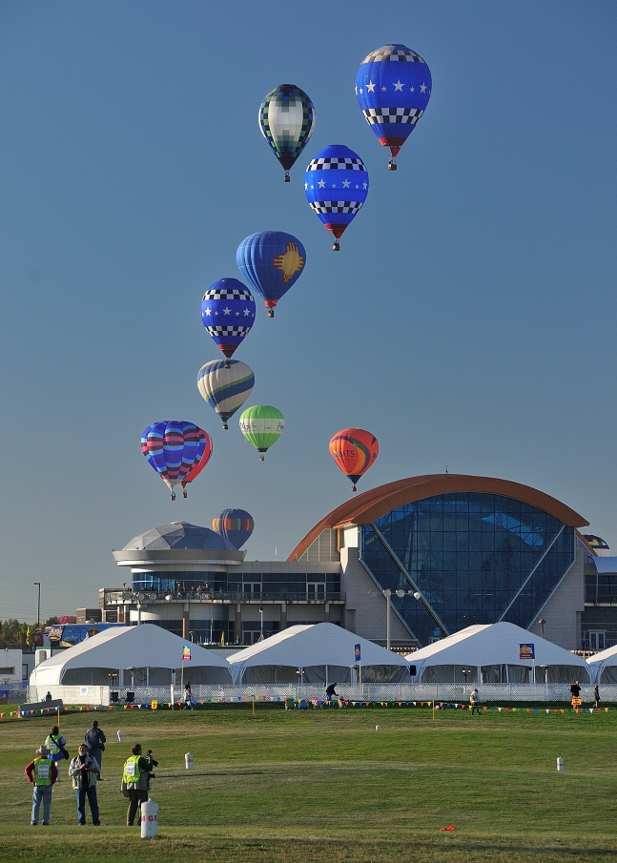
Anderson-Abruzzo Albuquerque International Balloon Museum
The museum is located at the south end of the Balloon Fiesta Launch Field. A shuttle runs between the field and the museum during Balloon Fiesta Sessions. The museum is a separate entity from AIBF, but supports the mission of education about hot air ballooning. The Diamond Club and Sky Boxes are special venues offered by the Balloon Museum.

Museum Hours during Balloon Fiesta
Daily 6:00 a.m. – 6:00 p.m.

Museum Admission:
- Adults: $4 (with $1 discount for New Mexico residents with a valid ID)
- Senior: $2 (65+)
- Children (ages 4-12): $1
- Children (3 and under): FREE

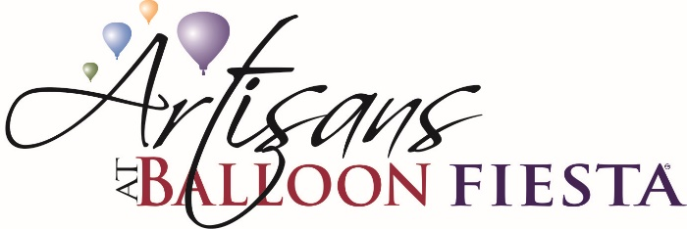
Artisans Tent
Artisans Art Show at Balloon Fiesta is located at the Balloon Fiesta Park on the north end of Main Street, next to the Balloon Discovery Center. This show is a juried event where Artists can showcase their best work.

ATMs
There are ATMs located on the north and south ends of Main Street as well as near the stage in the middle of Main Street.

Baby Changing Stations
Each of the 4 permanent toilet buildings located east of Concession Row have diaper-changing stations.

Backpacks and Coolers
Backpacks and coolers are allowed, but are subject to inspection upon entering the Park. Glass and alcohol are not allowed.

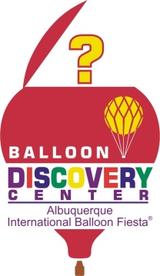
Balloon Discovery Center (BDC)
The Balloon Discovery Center (sponsored by 7-Eleven) educates guests about the fundamentals of ballooning. Admission is free once inside the park.

Exhibits include:
- The Albuquerque Box Effect – explains the famous “Albuquerque Box” effect
- Wicker Weaving – hands-on experience weaving a hot air balloon basket
- The new touchscreen balloon competition game where you get to “fly” a balloon and drop your baggie near the target!
- Balloon Flight Simulation on the Computer
- Craft Area where children can make their own souvenir from Balloon Fiesta
- Balloon Simulator – Interactive 3-D exhibit demonstrating the skills of a pilot
- Remote-Controlled Balloons
- Balloon Discoverer Passport
- And more!
The Balloon Discovery Center is located at the north end of Main Street. It is open every morning of Fiesta from 6:00-11:00 a.m. and during the evening sessions from 4:00-7:00 p.m.

Balloon Glow / Night Magic Glow / Twilight Twinkle
All are static (non-flight) displays of the balloons after sunset. The Balloon Glow is the name of the original glow event and occurs on the first Sunday night. The Night Magic Glow occurs on the second Saturday night.

Bicycles
Bicycles are not permitted inside Balloon Fiesta Park.

Bike Valet
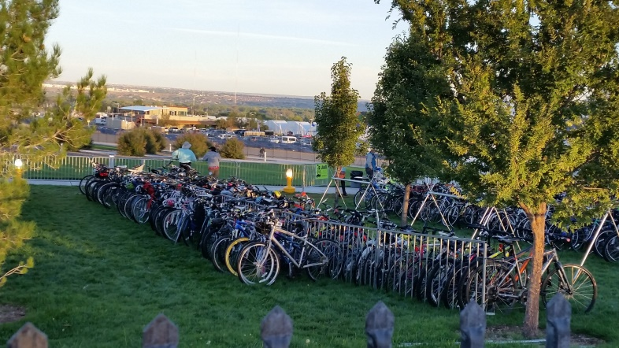
FREE Bike Valet has been established for individuals wishing to ride their bikes to Balloon Fiesta to avoid congested traffic and parking conditions.

The bike trail runs along the AMAFCA North Diversion Channel crosses underneath Paseo del Norte and Alameda Blvd. continuing north where it crosses from the west side of the AMAFCA channel to the east side, ending just north of the Balloon Museum. There you will find the Bike Valet staffed by local bicycle group volunteers. A two-part ticket with one half going to the rider and the other half securely attached to the bike will be issued to the rider.

Bike Valet hours of operation:
Morning Sessions 5:30 - 10:30 a.m.
Evening Sessions 5:00 - 9:00 p.m.

Bikes not picked up from the bike valet area will be removed and stored. The bike owner will have to call the Balloon Fiesta main line at 821-1000 to arrange pick up.

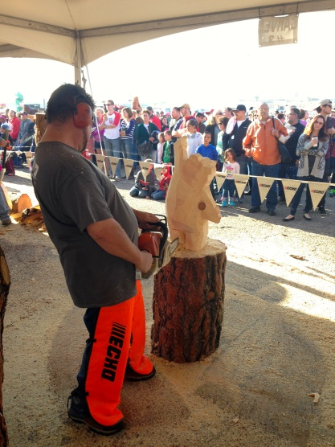
Chainsaw Carving Invitational
The Chain Saw Carving event is held in a tent on the north end of the field. See the Schedule of Events for exact dates and times.

Chase Crews
Chase crews help the pilot inflate and deflate his/her balloon for each flight. If you are interested in being on a chase crew visit the Information Booths for instructions.

There are many balloons that are in need of crew members. This is particularly true of balloons coming from outside the Albuquerque area which may not be able to bring their hometown crew. This can be for a one-time session or for multiple sessions and experience is not required. A member of the Chase Crew Committee will place the person with a pilot who needs crew.

Additionally, Chase Crew members can register during Pilot Registration.

Chase Crew members must be able to take instructions from the pilot and crew chief, lift heavy objects, climb in and out of a truck-bed, and deal with large crowds.

Chasers’ Club
Chasers’ Club is a special outdoor dining area for guests who would like to upgrade their Balloon Fiesta experience. It is offered on a per session basis and include event admission, a light hot meal, and guaranteed seating. A cash bar is available. The Chasers’ Club is located on the north end of the field, west of Main Street. Tickets are $45 per session (Children under 6 are free).

Once orders have been processed there are no refunds. Tickets may be used as a rain check for GENERAL ADMISSION to an alternative session. Due to seating capacity guests will NOT be allowed to transfer their ticket to another Chasers’ Club Session. The Chasers’ Club does NOT close if a flying event has been cancelled. It is still open for the food, entertainment and access to other park activities.

Competitions
Pilots compete in such events as Balloon Fiesta Hold 'em, Key Grab, Balloon Fiesta Golf, Multiple Judge-Declared Goal, Fly-in Task, minimum Double Drop and a Ring Toss. All competitions are based on flying accuracy rather than speed. The competitions take place on Monday, Tuesday, Thursday and Friday, with the scores being compiled. To keep track of each day’s results go to http://www.balloonfiesta.com/pilots-and-crew/competition-scores

Concession Headquarters
Concession Headquarters is located north of the Public Safety building and is open 4:30-10:00 a.m. for morning sessions and 4:00-8:00 p.m. for evening sessions. The information booths have complete listings of the concessions.

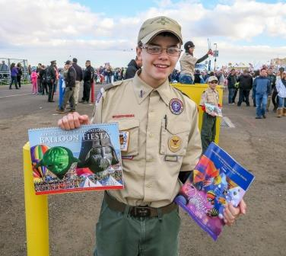
Contract Organizations
Balloon Fiesta contracts with several organizations to run certain operations throughout the event. Most of these organizations staff their operations with smaller non-profits. Members of these smaller non-profits may be volunteering for the first time and looking for the headquarters of their group.
These include:
- Community Link –South Merchandise Tent, Gondola Club and Sponsor Hospitality Merchandise areas, and program and calendar sales
- Daughters of the Nile –North Merchandise Tent
- N&D Sports – Strolling sales of glow products and other misc. items. Headquarters are located east of the Main Street Cantina.
- Kiwanis Club –Admission booths. Their headquarters is located near gate 12 on Magic Avenue.
- Civitans –Parking lots and fee-for-parking areas. Their headquarters is located outside Gate 14A at the top of Gondola Gulch.

Corporate Village / Sponsor Hospitality
This area is located on the south end of the field. A special pass is needed for this area. (This is no longer called the VIP area.)

Courtesy Shuttles
A variety of Courtesy Shuttles are available for transportation inside and around Balloon Fiesta park:
- In-Field
- Field-to-Parking Lots
- Field-to-RV Lot
- Field-to-Museum (these are run by the museum)
These carts are free to Balloon Fiesta guests, but are intended as priority for the handicapped, elderly and those with mobility issues. Carts are designated with signage and can be summoned at the Information Booths, Public Safety or at various stops.

Dates
Balloon Fiesta takes place every October, starting on the first Saturday through the second Sunday. Upcoming dates are and October 6-14, 2018.

Dawn Patrol
Dawn Patrol is a group of selected balloons that launch prior to sunrise on the days of Mass Ascensions. They help determine what the flying conditions are aloft, and are specially outfitted and licensed to fly in the dark.

Entertainment
Besides the balloons, there is a stage located in the center of Main Street that schedules various bands and children's acts. We also have strolling entertainment along Main Street and on the new North Stage located in front of the Balloon Discovery Center.

See the Entertainment Schedule in the Survival Guide for more information or visit http://balloonfiesta.com/event-info/entertainment-schedule

Family Resources
Strollers, wheelchairs and electric scooters are available for rent on a first come, first serve basis near the North and South Information Booths.

The New Mexico State Police will be at Balloon Fiesta during each session with their TAG YOUR TOTS program. Adults can register their children with the State Police and have a wristband placed on each child. If the child becomes lost they will know who their parents/guardians are and have contact information for that particular parent. The TAG YOUR TOTS location is just south of the Main Stage.

First Aid
First Aid is located in the Public Safety Building southeast of the Main Stage. If you need assistance, contact any public safety officer.

Flags
Near the main stage large flag pole utilizing is a system of notification flags. RED = cancelled launch. YELLOW = delayed launch or pending decision. GREEN = Balloons will launch!

Flight of the Nations
Flight of the Nations is an event held during the Wednesday Mass Ascension. It honors all of the countries that are represented in Balloon Fiesta. Up to two balloons from each country launch after the "Sponsor of the Day" balloon launches. Each balloon will carry its country's flag.

Food and Drink
There are food vendors at Balloon Fiesta Park serving a variety of foods. There is over 1/3 of a mile of concessions on the field. There are 3 cantinas located along Main Street – at the Sid Cutter Pilots’ Pavilion, in the center of Main Street east of the Main Stage, and adjacent to the Chasers’ Club. There will also be a beer garden set up during Music Fiesta, located to the east of the mobile stage.

Gates Times
The park opens at 4:30 a.m. for morning activities, and again at 3:00 p.m. for the evening activities and is open until approximately 9:00 p.m. Most concessions close during midday and there is not balloon activity during the midday hours. For Music Fiesta, please see the Music Fiesta FAQs.

Gate Numbers
As of 2016, the gate numbers throughout Balloon Fiesta Park have changed. Please check the gate nearest you to confirm the correct number.
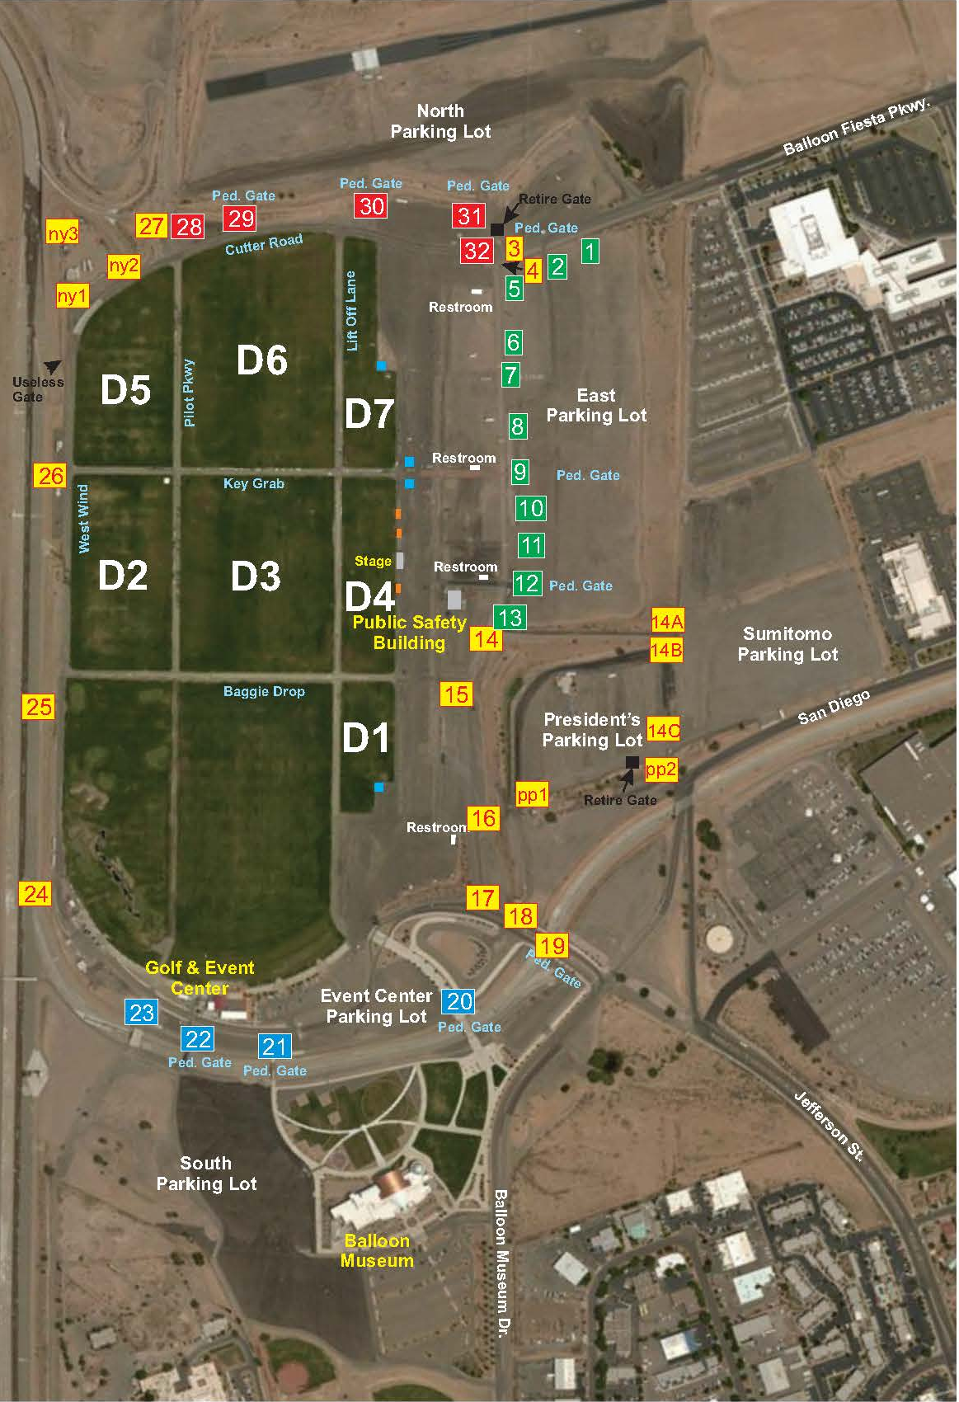

Gift Shop
The Albuquerque International Balloon Fiesta Gift Shop is open year-round Monday-Friday, 9:00 a.m. – 5:00 p.m.

Additional hours include:
The 2 Saturdays in September immediately prior to Balloon Fiesta: 9:00 a.m. – Noon
Both Saturdays during Balloon Fiesta: 8:00 a.m. – 5:00 p.m.
The first Sunday during Balloon Fiesta: 8:00 a.m. – 5:00 p.m.

The Gift Shop features Official Balloon Fiesta merchandise, tickets, passes, and more.
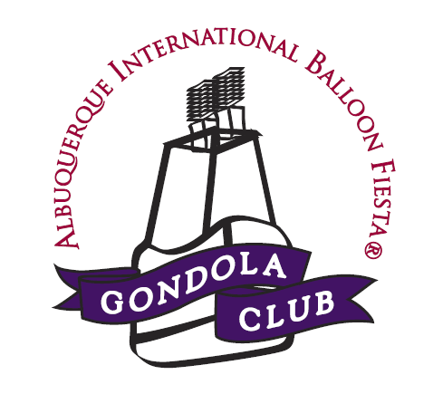

Gondola Club
The Gondola Club is the premiere all-inclusive dining area offering guests a first-class experience at Balloon Fiesta. Tickets are sold on a per session basis and are not a membership. It is located at the Southwest Corner of the field. Gondola Club Hours of Operation are: 5:30-10:00 a.m. for morning sessions and 5:00-9:00 p.m. for evening sessions.

Prices are per session. | Adult | Child, Ages 4-12  (Ages <3 are free)
1-13 People - Per person, per session (except Monday, Tuesday, or Wednesday mornings) | $110 | $55
14+ People - Per person, per session (except Monday, Tuesday, or Wednesday mornings) | $95 | $47.50
A 3% Convenience (ticketing) Fee is applied to all tickets.

Gondola Club tickets include:
- Admission to Balloon Fiesta
- Parking pass to nearby, private Gondola Club parking
- Delicious buffet meal (breakfast or dinner buffet, depending on session attended)
- Host (open) bar
- Prime location for viewing hot air balloon launch
- Shuttle transportation to and from parking area and Main Street
- Dedicated bathrooms
- Live entertainment at evening sessions
- Collectible Gondola Club lapel pin
- Gondola Club souvenir gift*

Handicap/ADA Accessibility
Balloon Fiesta has handicap parking on a hard surface close to entrance gates. It is available for the regular parking fee ($15) for each session.

Handicap Balloon Fiesta Parking passes are available by bringing a photo of the handicap license plate or a placard into the Balloon Fiesta Office during regular hours. These passes are preferred as they have a reflective “H” on them. Parking in Handicap Parking is on a first come, first served basis and is not guaranteed.

Mobility scooters and wheelchairs are available for rent. Courtesy Shuttles run the length of the park and into the parking lots. ADA toilets are available at all porta-potty banks and in each permanent toilet trailer.

Hospitality
Hospitality areas for sponsors, media, pilots and Navigators have been established at Balloon Fiesta. Only those with proper credentials may access these areas.
- Sponsor Hospitality is located on the south end of the field.
- Pilot and Crew Hospitality is located at the Sid Cutter Pilots’ Pavilion which is on the South end of the field near the end of Main Street.
- Navigator Hospitality is located slightly northeast of the Sid Cutter Pilots’ Pavilion near the blue awning.
- Media Hospitality is located just south of the Sid Cutter Pilots’ Pavilion.

In and Out Privileges
There are no “in and out” privileges associated with Balloon Fiesta general admission. Some Music Fiesta tickets do allow “in and out” privileges.

Information Booths
Information Booths are located north and south ends of Main Street as well as north of the stage in the middle of Main Street. They are open from 5:00-10:00 a.m. on Saturday and Sunday, 5:30-10:00 a.m. Monday-Friday. For evening sessions the Information Booths are open from 3:30-8:30 p.m.

Launch Field/Sites
Specific launch sites can be located by using the Balloon Fiesta app, downloadable at http://www.balloonfiesta.com/guest-guide/directions-maps

Launch sites use a combination of letter and number designation.
Sites lettered from the south to north, starting with the letter “A” ending in “W.”
They are then numbered from east to west, starting with the number “1” ending at “11.”

Balloon Fiesta Park is over 360 acres. The launch field is over 80 acres itself.

Lawn Chairs/Seating
Lawn chairs are allowed at Balloon Fiesta Park but are subject to search. There are a limited number of benches and seats located around the park.

Lost and Found
People who have lost items should be directed to the Public Safety Building. Likewise, all found items should be taken to the Public Safety Building. Items not claimed by the end of Balloon Fiesta will be taken to the Balloon Fiesta office where they can be claimed.

Main Stage
The Main Stage (sponsored by Sandia Resort and Casino) is located in the center of and on the west side of Main Street. Free live entertainment is offered throughout most of the event. See the Entertainment Schedule in the Survival Guide for more information or visit http://balloonfiesta.com/event-info/entertainment-schedule

Main Street/Concession Row
Main Street or Concession Row is the main pedestrian area located east of the launch field. It features over 1/3 mile of food, beverage and souvenir sales.

Mass Ascensions
A mass ascension is when all 550+ balloons launch from Balloon Fiesta Park in approximately a two hour time frame.

Merchandise
Official Balloon Fiesta merchandise can be purchased online at http://www.balloonfiestastuff.com

Merchandise Tents
There are two official Balloon Fiesta merchandise tents located near the north and south ends of Main Street. The merchandise tents are open:

Thursday prior to event | 9:00 a.m. – 5:00 p.m.
Friday prior to event | 9:00 a.m. – 5:00 p.m.
First Saturday | 5:30 a.m. - 9:00 p.m.
First Sunday | 5:30 a.m. - 9:00 p.m.
Monday | 5:30-11:00 a.m.
Tuesday | 5:30-11:00 a.m.
Wednesday | 5:30-11:00 a.m.
Thursday | 5:30-11:00 a.m. and 4:30 -9:00 p.m.
Friday | 5:30-11:00 a.m. and 4:30 -9:00 p.m.
Second Saturday | 5:30 a.m. - 9:00 p.m.
Second Sunday | 5:30-11:00 a.m.

Music Fiesta
Music Fiesta takes place on the second Saturday of the event between the morning and evening sessions. The Music Fiesta Line-up and schedule are as follows. (Check www.BalloonFiesta.com for more details and performers.)
10:00 a.m. | Gates Open for Music Fiesta entry
12:00 Noon | Seating areas open
1:00 p.m. | Music Begins – Local or Regional Performer
2:30 p.m. | Support Band
4:00 p.m. | Headliner
6:00 p.m. | Night Magic Glow™

Music Fiesta ticket prices:
 | In advance | Day of Show
Ultimate Music Fiesta Package (Ticket required for persons of all ages.)  (Includes: 1 Reserved Seat in the front rows of Section A, B or C, Meet & Greet with headliner or opener, 1 Photo Opportunity with headliner or opener,1 current CD by headliner, 1 current CD by opener, 1 Signed Music Fiesta Poster, 1 VIP Laminate, 1 Gondola Club Dinner Session Ticket following the concert, 1 Balloon Fiesta jacket or vest, 1 Balloon Fiesta Cap, 1 Sunscreen Kit, Private Entrance Access, Preferred Parking) | $499 | Not available
ABQ Dance Box (Ticket required for persons of all ages.) | $69 | $79
Reserved Seating (Ticket required for persons of all ages.) | $50 | $60
Premier Lawn Area (Children 12 and under get in to the Premier Lawn Seating area for free.) | $20 | $25
General Admission (Children 12 and under get in to the General Admission area for free.) | $10 | $10

Music Fiesta ticket includes admission for the Night Magic Glow™ and AfterGlow™ fireworks show.

More information about Music Fiesta can be found at http://balloonfiesta.com/event-info/music-fiesta-faqs

Officials
Balloon Fiesta flight operations are overseen by approximately 120 Officials working on 7 different teams:
- Balloonmeister
- Assistant Balloonmeister
- Safety Officials
- Weather Officials
- Launch Directors
- Landowner Relations
- Scoring Officials

Parking
Balloon Fiesta has general parking lots on the north and south ends of the park for $15 per session. Each parking lot is color-coded and the gates are numbered, so please remember the color and number of the gate through which you entered the field.

Parking Lot Locations
- Red Parking: Located north of the Launch Field at Balloon Fiesta Park includes handicap parking, general parking and chase crew parking.
- Green Parking: Located east of the Launch Field at Balloon Fiesta Park includes preferred parking and parking east of President’s Compound which is on top of Gondola Gulch.
- Blue Parking: Located south of the Launch Field at Balloon Fiesta Park includes chase crew parking, general parking and handicap parking.

Park & Ride – Fiesta Express
Balloon Fiesta Express is a shuttle bus service from various parking locations outside of Balloon Fiesta Park. It is an effort to help guests avoid traffic congestion and limited prime parking spaces. The price of the Park & Ride ticket includes admission into the event. Park & Ride picks up riders leaving the park at the Park & Ride Depot, located at the southeast corner of the field.

Park & Ride Tickets:
ADVANCE TICKETS  Valid before 12 Midnight for morning sessions or before 12 Noon for afternoon/evening sessions. | Adults (13-61) | $15.00
 | Seniors (62 & older) | $12.00
 | Children (6-12) | $7.00
 | Children (5 and under) | Free
SAME-DAY PURCHASE AT PARK & RIDE LOCATIONS  Event admission is included.  Tickets purchased after 12 Midnight for morning sessions or after 12 noon for afternoon/evening sessions. | Adults (13-61) | $22.00
 | Seniors (62 & older) | $20.00
 | Children (6-12) | $10.00
 | Children (5 and under) | FREE

Tickets may be purchased in advance online at www.balloonfiesta.com or at the Balloon Fiesta Gift Shop.

Park & Ride Hours of Operation:

 | Departures | Returns | Limited schedule thereafter.
First Saturday | 4:30 – 7:00 a.m. | 8:30 - 11:30 a.m.
 | 3:30 – 6:30 p.m. | 7:30 - 9:30 p.m.
First Sunday | 4:30 – 7:00 a.m. | 8:30 - 11:30 a.m.
 | 3:30 – 6:30 p.m. | 7:30 - 9:30 p.m.
Monday | No Park & Ride Service
Tuesday
Wednesday
Thursday | 5:00 – 7:00 a.m. | 8:30 - 11:30 a.m.
 | 3:30 – 6:30 p.m. | 7:30 - 9:30 p.m.
Friday | 5:00 – 7:00 a.m. | 8:30 - 11:30 a.m.
 | 3:30 – 6:30 p.m. | 7:30 - 9:30 p.m.
Second Saturday | 4:30 – 7:00 a.m. | 8:30 - 11:30 a.m.
 | 3:30 – 6:30 p.m. | 7:30 - 9:30 p.m.
Second Sunday | 4:30 – 7:00 a.m. | 8:30 - 11:30 a.m.

* Weekday morning buses will run every ½ hour from remote lots or as they become available. After full service ends at 11:30 a.m. and 9:30 p.m., limited bus service will continue until all guests have departed.

Park & Ride Locations:
- East Side
  - Hoffmantown Church located at 8888 Harper Road NE, Park in the northeast lot only.
  - Coronado Mall located at 6600 Menaul Boulevard NE, park in the southwest corner near San Pedro
  - Cliff’s Amusement Park located at 4800 Osuna Rd. NE, near San Mateo and I-25.
Note: Cliff’s Park & Ride location is valid for advance ticket purchases only. No on-site ticket sales are available.
- West Side
  - Intel (southern parking lot) located on Highway 528/Rio Rancho Blvd. Enter the Park & Ride lot at either Westside Blvd. or 21st street and follow the signs.
  - Cottonwood Mall (northeast parking lot) located at 10000 Coors Bypass near Seven Bar Loop.

Park Cleanliness
Everyone needs to do their part in keeping the event clean and inviting. Pick up garbage is you see it. If you notice an area in need of particular attention, notify Public Safety or your Team Leader and ask them to contact the Field Staff.

Personal Items
In general there are no secure locations for volunteers to store their personal items. It is highly recommended that you carry your items with you. It is also recommended that items such as jackets, hats, etc. are labeled with your name in the event that it is misplaced. Albuquerque International Balloon Fiesta is not responsible for any items lost or stolen.

Pets
Pets are NOT allowed at Balloon Fiesta Park, except Service Animals.

Pilot Registration
Pilot Registration takes place is located in the Sid Cutter Pilots’ Pavilion on the southeast corner of the Launch Field. Pilot Registration takes place on the Thursday and Friday immediately prior to the start of Balloon Fiesta.
Thursday 10:00 a.m. – 7:00 p.m.
Friday 10:00 a.m. – 7:00 p.m.

Pin Trading Day
Pin trading day is an opportunity to build the ballooning community, nurture friendships and share enthusiasm about the sport of Hot Air Ballooning. It is held twice a year and enthusiasts from all over the world come to swap pins and share stories (some of them may even be true!). The participation of our future balloonists is encouraged – children are given some pins to trade. And there is a pin board just for them, with the adage of “take one, leave one.” Pin Trading Day takes place on the first Sunday and the Second Saturday at 11:00 a.m. in the Group Tours Tent.

Public Restrooms
Public restrooms are located near the main entrances behind (East of) Main Street, and also the north, south and west sides of the Launch Field. Three large restroom plazas are located on the north side of the walkways, north of the Public Safety Building. Handicap and Diaper Changing/Family Bathrooms are located in the 4 permanent toilet buildings east of Main Street.

Public Safety
The Public Safety Team includes law enforcement, fire safety and a private safety and security team responsible for overseeing the safety and security of all people at Balloon Fiesta. They coordinate with local, state and federal law enforcement and emergency response agencies to ensure that Balloon Fiesta is safe for everyone present.

The Public Safety Building is located directly east and slightly south of the Main Stage. It houses Lost and Found, the Public Safety Command Post, and the Lovelace First Aid Center.

Public Safety can be reach by calling 505-821-7300.

Radio
KKOB is the official radio station of Balloon Fiesta. Tune into 770 AM for updates on weather, traffic, and the event.

RVs
Balloon Fiesta has several areas for parking RVs, all within walking distance to the field. For further details contact Jennifer Garcia at the AIBF office at (505) 821-1000 ext. 107 or visit http://www.balloonfiesta.com/guest-guide/rv-information

Sessions
A session is all the activities taking place during a certain time frame. Balloon Fiesta has morning sessions each day of the event and evening sessions on 5 of those days. An example would be when you visit the park to see the Dawn Patrol and Mass Ascension, you would be coming to a morning session.

Smoking
Smoking is not allowed anywhere within Balloon Fiesta Park. The proximity of propane and other fuel tanks makes it very dangerous and ash can burn holes in balloon envelopes. Please ask the smoker to put out their item immediately.

Special Shape Rodeo
The Special Shape Rodeo is where special shape balloons are showcased at Balloon Fiesta and will also have a "Glowdeo" in the evening. A "Glowdeo" is a static display of the Special Shape balloons. Special Shape balloons can be shaped like almost anything you can imagine. Some examples include a stagecoach, piggy bank or a cow.

Souvenirs
Souvenirs may be purchased online at www.balloonfiestastuff.com, at Balloon Fiesta's gift shop year round, or on the Park at the official Balloon Fiesta Official Merchandise Tents at the north and south ends of the fields.

Survival Guide
The Balloon Fiesta Survival Guide is print each year as a comprehensive guide and map for the event. It is distributed to guests as they enter the pedestrian gates, and can be found at the Information Booths.

Tag Your Tots
See Family Resources above.

Tickets (General Admission)
Advance tickets are available at Balloon Fiesta's Gift Shop at 4401 Alameda Blvd. NE or online at www.balloonfiesta.com/guest-guide/ticketing-information. General Admission tickets may also be purchased at the gate on the days of the event. One ticket per person is needed per session.

Traffic
Since crowds for some of our events are in excess of 50,000 people, arriving earlier is better. For weekend events, plan to arrive at the park by 4:30-5:00 a.m. During evening events, try to be at the park by 4:00 p.m. Gates open at 4:30 a.m. and 3:00 p.m.

Transit Area
The transit area is located near gate 20 for the hotel shuttles, taxis, RV lot shuttles, Corporate Village shuttles, courtesy shuttle to the Handicap parking and Balloon Museum Shuttle.

Volunteering
Navigators (volunteers) are the heart of Balloon Fiesta. If someone is interested in volunteering, direct them to the Navigator Hospitality Tent or http://www.balloonfiesta.com/operations/volunteering.

Weapons
No weapons are allowed within Balloon Fiesta Park property.

Weather
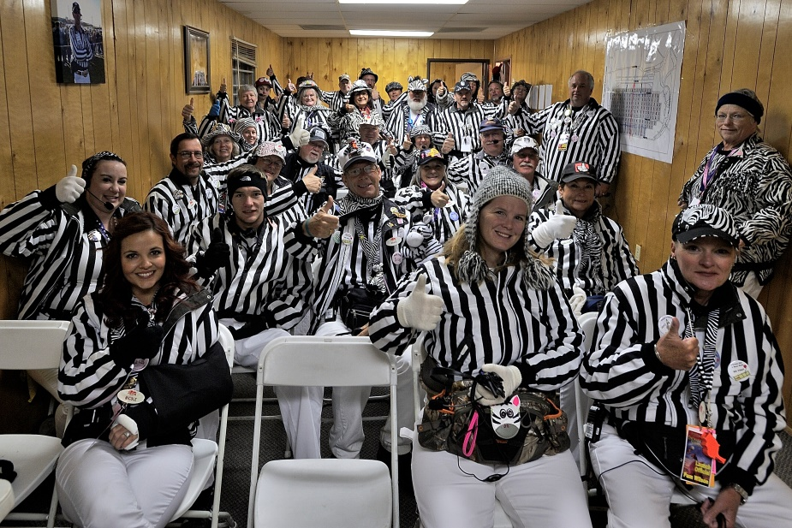
Generally, Albuquerque temperatures in the morning are around 20-40°F, warming up to about 50-70°F by noon. Bring a jacket and dress in layers. Also remember to wear comfortable, closed-toe walking shoes. Bring sunscreen to put on after the sun is up. You will be at a high altitude and are at risk for sunburn. Bring appropriate eye protection. Sun and wind could be your enemies on a bright, sunny or windy day.

Zebras (also known as Launch Directors)
They help launch the balloons every morning. The reason they are called Zebras is that they wear black and white striped shirts or jackets.

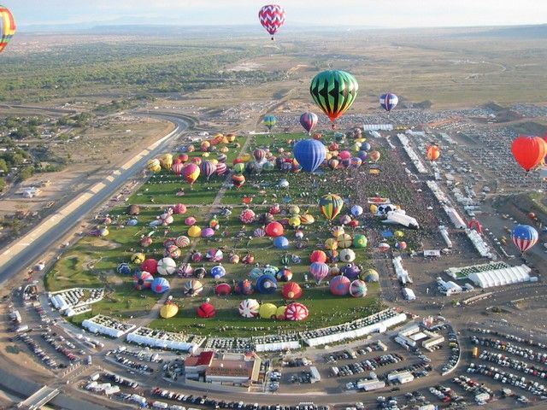
APPENDIX 1 – FORMS

Incident Report
Cash Count Worksheet
INCIDENT REPORT
All incidents involving injury, crime, or property damage should be immediately reported to Public Safety. This form is to be used for any incidents not involving injury, crime or property damage.

Date
Navigator | Team Leader
Name | Name
Phone | Phone
Incident

Date
Time
Location
Description of Incident

Witnesses

Action to be taken

By signing this document, you acknowledge that you have read and understood the information contained herein
Navigator | Date
Team Leader | Date
AIBF Staff Person | Date

CASH COUNT WORKSHEET

Date: Area:

Event:

COUNTER 1
Name:
COINS
Pennies |  | X 0.01 =
Nickels |  | X 0.05 =
Dimes |  | X 0.10 =
Quarters |  | X 0.25 =
.50 Piece |  | X 0.50 =
1.00 Piece |  | X 1.00 =
TOTAL COINS

CURRENCY
Ones |  | X 1.00 =
Twos |  | X 2.00 =
Fives |  | X 5.00 =
Tens |  | X 10.00 =
Twenties |  | X 20.00 =
Fifties |  | X 50.00 =
Hundreds |  | X 100.00 =
TOTAL CURRENCY

Total Coins (from above)
Total Currency (from above)
Total Checks (attached addition tape)
Total to be Deposited

Signature:

Employee Signature:

COUNTER 2
Name:
COINS
Pennies |  | X 0.01 =
Nickels |  | X 0.05 =
Dimes |  | X 0.10 =
Quarters |  | X 0.25 =
.50 Piece |  | X 0.50 =
1.00 Piece |  | X 1.00 =
TOTAL COINS

CURRENCY
Ones |  | X 1.00 =
Twos |  | X 2.00 =
Fives |  | X 5.00 =
Tens |  | X 10.00 =
Twenties |  | X 20.00 =
Fifties |  | X 50.00 =
Hundreds |  | X 100.00 =
TOTAL CURRENCY

Total Coins (from above)
Total Currency (from above)
Total Checks (attached addition tape)
Total to be Deposited

Signature:

Employee Signature:

